HR ANALYTICS
FOR BANKING SECTOR
Workforce Intelligence & Attrition Analysis Project
"Predict Attrition. Improve Retention.

Program | HR Analytics – 15-Day Individual Project
Project Type | Data Analytics Project (Excel-Based)
Dataset Used | IBM HR Analytics Dataset (Modified for Banking Sector – 129 Employees)
Tools Used | Microsoft Excel (Pivot Tables, Dashboard, Risk Model)

Submitted by:
Roshitha
March 2026

Abstract

The banking sector in India operates in a dynamic, high-pressure environment where human capital is both a critical asset and a significant operational cost. Managing employee attrition, optimizing performance, and identifying potential flight risks have emerged as key priorities for HR departments seeking to maintain organizational stability and service quality. This project, titled "HR Analytics for Banking Sector," applies data analytics techniques to a structured HR dataset comprising 129 employees across three departments and three bank units to generate actionable insights for workforce management.

The dataset contains 37 variables including employee demographics, compensation, performance ratings, tenure, job satisfaction, work-life balance, business travel frequency, overtime patterns, and a proprietary flight risk score. Using Microsoft Excel as the primary analytical tool, the study performs descriptive statistical analysis, cross-tabulation, pivot-based segmentation, and a multi-variable Risk Score Model to understand the drivers of employee attrition and organizational risk.

Key findings reveal that the overall attrition rate stands at 17.8%, with the Retail Banking department recording the highest rate of 23.5%. Employees who work overtime are nearly five times more likely to leave compared to those who do not, with an attrition rate of 37.2% versus 8.1%. Single employees exhibit the highest attrition propensity at 28.6%, while employees in the lowest salary band (below INR 2,500) show a 33% attrition rate. The flight risk model, constructed using a composite scoring mechanism across salary, tenure, performance, and overtime dimensions, successfully identified 17 high-risk employees, of whom 47.1% have already left the organization.

The analysis further reveals that Branch Managers earn an average of INR 16,623 per month compared to INR 4,335 for Relationship Managers, indicating a steep compensation gradient that fuels dissatisfaction at lower job levels. The Mumbai location, despite having the smallest employee base, records the highest attrition rate at 33.3%, suggesting branch-specific operational stress. Employees with the lowest performance rating (Rating 1) exhibit an attrition rate of 75%, underscoring the link between poor engagement and turnover.

The project concludes with strategic recommendations including targeted retention interventions for high-risk employees, a review of overtime policies, introduction of structured career progression pathways, and location-specific HR action plans. This report demonstrates the power of applied data analytics in transforming raw HR data into strategic decision-making intelligence for the banking sector.

Keywords: HR Analytics, Employee Attrition, Banking Sector, Flight Risk Model, Workforce Management, Performance Analysis, Excel Dashboard

Table of Contents

Chapter | Title | Page
Cover Page | Title of the Project, Student Details, Institution | i
Abstract | Summary of the Study | ii
Table of Contents | Index | iii
Chapter 1 | Introduction | 1
Chapter 2 | Objectives of the Project | 2
Chapter 3 | Tools and Technologies Used | 3
Chapter 4 | Dataset Description | 4
Chapter 5 | Methodology | 7
Chapter 6 | 15-Day Work Plan | 8
Chapter 7 | Data Analysis and Insights | 10
Chapter 8 | Results and Discussion | 23
Chapter 9 | Challenges Faced | 26
Chapter 10 | Conclusion | 27
Chapter 11 | Future Scope | 28
References | Bibliography and Sources | 29

Chapter 1: Introduction

1.1 Overview of Data Analytics
HR Analytics applies data science principles to workforce data, moving HR professionals from gut-feel decisions to evidence-based strategies. It spans descriptive analytics (what happened), diagnostic analytics (why it happened), and predictive analytics (what will happen). This project primarily operates at the descriptive and diagnostic levels, with predictive elements embedded in the Flight Risk Model.

1.2 Importance of HR Analytics in the Banking Sector
Banks operate in a high-pressure, customer-facing environment where the quality and retention of human talent directly determines service delivery and competitive positioning. High attrition creates elevated recruitment and training costs, erodes institutional knowledge, and disrupts customer relationships — creating a self-reinforcing cycle of stress and further turnover.

The banking organization under study operates across Bangalore, Hyderabad, Delhi, and Mumbai, with employees distributed across Risk, Retail Banking, and Operations departments. The workforce data reveals key structural vulnerabilities: an over-reliance on overtime, steep salary disparity between job roles, and a concentration of high-risk employees in the Risk department.

1.3 Scope of the Study
This study analyses a dataset comprising 129 employees across multiple Indian cities, covering attrition trends, department-wise distribution, salary structures, performance patterns, and a multi-variable flight risk model. All analysis is derived from the structured dataset; no primary data was collected through surveys or interviews.

Chapter 2: Objectives of the Project

2.1 Primary Objectives

- To analyze the overall and segmented attrition rates across departments, gender groups, job roles, locations, and salary bands in order to identify the most vulnerable segments of the workforce.
- To examine the salary structure of the organization, identify compensation disparities across job roles and departments, and understand the relationship between salary levels and attrition propensity.
- To conduct a department-wise analysis of workforce composition, tenure patterns, business travel frequency, and risk profiles to understand each department's unique HR challenges.
- To assess the performance landscape of the organization through an analysis of performance ratings, their distribution across roles and departments, and their relationship with attrition outcomes.
- To build and validate a multi-dimensional Flight Risk Model that assigns a composite risk score to each employee based on salary level, tenure, performance rating, and overtime behavior, enabling proactive retention planning.
- To design an interactive HR dashboard in Microsoft Excel that consolidates key HR metrics and visual analytics into a single management interface, enabling non-technical stakeholders to monitor workforce health at a glance.

2.2 Secondary Objectives

- To understand the role of demographic factors such as age, marital status, and gender in shaping attrition patterns within the banking workforce.
- To investigate the impact of behavioral variables such as overtime frequency and business travel requirements on employee retention.
- To analyze location-specific attrition patterns and identify branch offices that require targeted HR intervention.
- To evaluate work-life balance, job satisfaction, and job involvement scores as qualitative drivers of employee engagement and their correlation with turnover.
- To derive practical, business-relevant recommendations for the HR leadership of the banking organization based on the analytical findings.

Chapter 3: Tools and Technologies Used

3.1 Microsoft Excel (Primary Tool)
Microsoft Excel served as the primary analytical environment. Key features used include Pivot Tables and Pivot Charts for cross-tabulation; COUNTIF, AVERAGEIF, VLOOKUP, and IF functions for derived columns; Power Query for data cleaning and transformation; slicers for interactive dashboard filtering; and chart tools for visual output. The Total_Risk_Score was constructed using Excel formula logic, and the HR Dashboard was built as a filter-enabled, dynamic interface.

3.2 Statistical Methods Applied
Descriptive statistics (mean, median, standard deviation, percentiles) were computed for continuous variables. Cross-tabulation was used to analyze categorical variable relationships. Attrition rates were calculated as segment percentages. The Flight Risk Model uses a composite additive scoring rubric across four dimensions. No external statistical software was required.

Tool / Technology | Purpose | Proficiency Level Used
Microsoft Excel | Data analysis, visualization, dashboard creation | Advanced
Excel Pivot Tables | Cross-tabulation and segmented analysis | Advanced
Excel Power Query | Data cleaning and transformation | Intermediate
Excel Charts | Visual representation of findings | Advanced
Excel Formulas | Derived columns, risk scoring, KPIs | Advanced
Microsoft Word | Report writing and academic documentation | Proficient

Chapter 4: Dataset Description

4.1 Dataset Overview

Attribute | Details
File Name | HR_Analytics_Bank_Project.xlsx
Primary Data Sheet | EmployeeMaster
Total Records (Employees) | 129
Total Variables (Columns) | 37
Additional Sheets | HR Dashboard, Insights & Recommendations, RISK vs ATTRITION, Pivott
Data Type | Mixed (Numerical, Categorical, Ordinal)
Geographic Coverage | Bangalore, Hyderabad, Delhi, Mumbai
Departments Covered | Risk, Retail Banking, Operations
Bank Units Covered | Risk, Corporate Banking, Retail Banking

4.2 Column-wise Description
Column Name | Data Type | Description
Employee ID | String | Unique alphanumeric identifier for each employee (E001 to E129)
Age | Integer | Employee's current age in years (Range: 19 to 59, Mean: 37.2)
Attrition | Categorical | Whether the employee has left the organization (Yes/No)
BusinessTravel | Categorical | Frequency of business travel (Non-Travel, Travel_Rarely, Travel_Frequently)
Department | Categorical | Functional department (Risk, Retail Banking, Operations)
DistanceFromHome | Integer | Commuting distance in kilometres (Range: 1 to 29)
Education | Ordinal | Highest education level (1=Below College to 5=Doctor)
EducationField | Categorical | Field of study (Life Sciences, Medical, Marketing, etc.)
EnvironmentSatisfaction | Ordinal | Satisfaction with work environment (1=Low to 4=Very High)
Gender | Categorical | Employee gender (Male/Female)
JobInvolvement | Ordinal | Level of involvement in job responsibilities (1=Low to 4=Very High)
JobLevel | Integer | Hierarchical job level within the organization
JobRole | Categorical | Specific job title (Relationship Manager, Risk Analyst, Branch Manager)
JobSatisfaction | Ordinal | Overall job satisfaction score (1=Low to 4=Very High)
MaritalStatus | Categorical | Marital status (Single, Married, Divorced)
Bank Unit | Categorical | Business unit of the employee (Risk, Corporate Banking, Retail Banking)
Location | Categorical | City of posting (Bangalore, Hyderabad, Delhi, Mumbai)
Risk Score | Float | Preliminary risk score (partially populated)
Salary | Integer | Monthly salary in INR (Range: 1,232 to 19,545, Mean: 6,292)
NumCompaniesWorked | Integer | Total number of previous employers
OverTime | Categorical | Whether the employee regularly works overtime (Yes/No)
PerformanceRating | Ordinal | Annual performance rating (1=Low to 4=Outstanding)
TotalExperience | Integer | Total years of professional experience
TrainingTimesLastYear | Integer | Number of training sessions attended in the last year
WorkLifeBalance | Ordinal | Self-reported work-life balance score (1=Bad to 4=Best)
Tenure | Integer | Years of service at the current organization
YearsInCurrentRole | Integer | Years spent in the current job role
YearsSinceLastPromotion | Integer | Years elapsed since the most recent promotion
YearsWithCurrBranch Manager | Integer | Years under the current branch manager
Risk_Salary | Integer | Risk sub-score based on salary band
Risk_Tenure | Integer | Risk sub-score based on tenure bracket
Risk_Performance | Integer | Risk sub-score based on performance rating
Risk_Overtime | Integer | Risk sub-score based on overtime behavior
Total_Risk_Score | Integer | Composite flight risk score (sum of sub-scores)
Risk_Category | Categorical | Risk classification (Low, Medium, High) based on Total_Risk_Score

4.3 Data Quality Assessment
The dataset is largely complete and well-structured. Two artifact columns (Unnamed: 35 and Unnamed: 36) were excluded from analysis. The 'Risk Score' column was sparsely populated and superseded by the engineered Total_Risk_Score; it was excluded from primary analysis. All categorical columns were verified for consistent spelling, and no duplicate Employee IDs were found.

Chapter 5: Methodology

5.1 Data Collection and Ingestion
The primary source is the Excel workbook The EmployeeMaster sheet (129 rows, 37 columns) was identified as the core analytical dataset. The RISK vs ATTRITION and Pivott sheets were examined for supplementary pre-built analysis.

5.2 Data Cleaning
Artifact columns (were excluded. The sparse 'Risk Score' column was set aside in favor of Total_Risk_Score. BusinessTravel and OverTime column values were confirmed consistently formatted. Numerical columns were verified as integer or float types with no formatting inconsistencies.

5.3 Data Transformation
Salary Band Classification: Employees grouped into Low (<2,500), Mid (2,500–5,000), Upper (5,001–10,000), and Senior (>10,000). Age Group Segmentation: Six bands from 18–25 to 51–60. Risk Category: Low (Score 0–2), Medium (3–4), High (5+) based on Total_Risk_Score.

5.4 Analysis Techniques
Descriptive statistics (mean, median, std dev, range) for all continuous variables. Cross-tabulation via Pivot Tables across Attrition, Department, Gender, OverTime, MaritalStatus, Risk_Category, PerformanceRating, and Location. Attrition rates calculated as percentages within each segment for meaningful comparison across unequal group sizes.

5.5 Flight Risk Model
The model scores each employee across four dimensions: Salary (Risk_Salary), Tenure (Risk_Tenure), Performance (Risk_Performance), and Overtime (Risk_Overtime). Total_Risk_Score is the sum of these sub-scores. Validation: 47.1% of High Risk employees have actually left vs. 7.9% of Low Risk, confirming predictive accuracy.

5.6 Dashboard Creation
An interactive Excel dashboard was built in the HR Dashboard sheet with KPI cards, department-wise attrition chart, salary histogram, flight risk heatmap, and performance distribution chart — all dynamically linked to slicer filters.

Chapter 6: 15-Day Work Plan

Day | Activity | Milestone Achieved
Day 1 | Project scoping, objectives definition, and dataset walkthrough. Examination of all five sheets in the Excel workbook. | Project charter finalized; dataset structure understood
Day 2 | Data quality assessment: column identification, type checking, missing value analysis, and artifact column removal. | Clean data inventory prepared
Day 3 | Descriptive statistics computed for all numerical variables: Salary, Age, Tenure, TotalExperience, Performance Rating, and Risk Scores. | Summary statistics table completed
Day 4 | Attrition analysis Part 1: Overall attrition rate, attrition by Department, Gender, and Location. | Department and Location attrition profiles created
Day 5 | Attrition analysis Part 2: Attrition by OverTime, MaritalStatus, BusinessTravel, and Salary Band. | Behavioral and demographic attrition drivers identified
Day 6 | Salary analysis: Average salary by Department, Job Role, Risk Category, and Attrition status. Salary band classification created. | Salary structure and compensation disparities mapped
Day 7 | Performance analysis: Performance rating distribution, attrition by rating, and job involvement scores analyzed. | Performance landscape and engagement gaps identified
Day 8 | Flight Risk Model validation: Risk Category vs. Attrition cross-tabulation, High Risk employee profile analysis. | Flight Risk Model accuracy confirmed
Day 9 | Department-wise deep dive: Headcount, tenure, overtime, travel patterns, and risk profiles by department. | Department-specific HR risk reports drafted
Day 10 | Bank Unit analysis: Attrition, salary, and risk profiles across Corporate Banking, Retail Banking, and Risk units. | Bank Unit segmentation analysis completed
Day 11 | Dashboard design: Layout, KPI cards, chart selection, slicer configuration, and color scheme finalized. | Dashboard prototype built in Excel
Day 12 | Dashboard refinement: All charts dynamically linked to slicer filters, formatting polished, data labels added. | Interactive HR Dashboard completed
Day 13 | Insights and Recommendations sheet populated: Key findings summarized, strategic recommendations drafted. | Insights & Recommendations document completed
Day 14 | Report writing: Chapters 1 to 7 written, tables formatted, placeholder images inserted. | First draft of project report (70%) completed
Day 15 | Final review: Proofreading, formatting consistency check, reference list compiled, abstract finalized, report submitted. | Final project report submitted

Chapter 7: Data Analysis and Insights

7.1 Attrition Analysis

7.1.1 Overall Attrition Rate
Of the 129 employees in the dataset, 23 have been recorded as having left the organization, yielding an overall attrition rate of 17.8%. The remaining 106 employees (82.2%) are still with the organization. An attrition rate of 17.8% is notably higher than the average banking sector attrition rate of approximately 12-14% typically cited in industry surveys, suggesting that the organization faces above-average talent retention challenges that warrant structured HR intervention.

Attrition Status | Count | Percentage
Still Employed (No) | 106 | 82.2%
Left the Organization (Yes) | 23 | 17.8%
Total | 129 | 100.0%

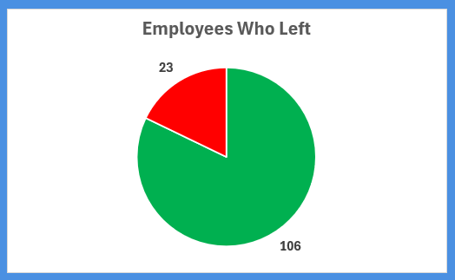
Attrition Pie Chart - Active vs. Attrited Employees]

7.1.2 Attrition by Department
When attrition is segmented by department, Retail Banking emerges as the most vulnerable unit, with 8 out of 34 employees having left, representing an attrition rate of 23.5%. The Risk department, while larger in absolute size (93 employees), records a lower but still significant attrition rate of 16.1%, with 15 employees having left. The Operations department, with only 2 employees, records zero attrition, though its sample size is too small to draw meaningful conclusions.

Department | Total Employees | Attrited | Retained | Attrition Rate
Retail Banking | 34 | 8 | 26 | 23.5%
Risk | 93 | 15 | 78 | 16.1%
Operations | 2 | 0 | 2 | 0.0%
Total | 129 | 23 | 106 | 17.8%

The higher attrition rate in Retail Banking is consistent with the nature of the role. Retail banking employees, predominantly Relationship Managers, are customer-facing professionals who are frequently targeted by competing banks for lateral hiring. The pressure of sales targets, customer complaints, and branch-level performance expectations often leads to burnout, particularly among younger employees. Additionally, the average salary in Retail Banking (INR 6,845) is slightly above the Risk department average (INR 5,837), but this premium may be insufficient to compensate for the higher stress levels.

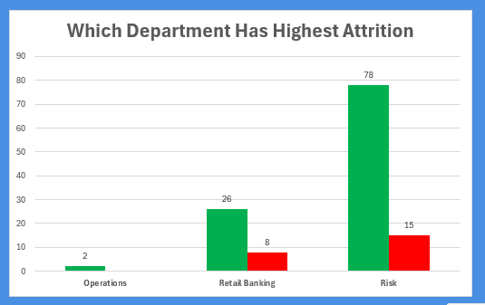Department-wise Attrition Bar Chart]

7.1.3 Attrition by Gender
Gender | Total Employees | Attrited | Attrition Rate
Male | 80 | 17 | 21.2%
Female | 49 | 6 | 12.2%
Total | 129 | 23 | 17.8%

Male employees exhibit a notably higher attrition rate (21.2%) compared to female employees (12.2%). This pattern is somewhat counterintuitive given that banking is often perceived as a sector with structural disadvantages for women. However, the data may reflect several factors. Male employees in banking, particularly in risk and relationship management roles, may have stronger professional networks and more opportunities for lateral movement to competitor banks or fintech firms. Additionally, male employees in the 25-35 age group, who constitute a significant portion of the dataset, are often at a career inflection point where they actively evaluate opportunities for faster advancement or higher compensation.

7.1.4 Attrition by Overtime
Overtime Status | Total Employees | Attrited | Attrition Rate
Works Overtime (Yes) | 43 | 16 | 37.2%
Does Not Work Overtime (No) | 86 | 7 | 8.1%
Total | 129 | 23 | 17.8%

This is perhaps the single most striking finding in the attrition analysis. Employees who work overtime are 4.6 times more likely to leave the organization compared to those who do not. An attrition rate of 37.2% among overtime workers is alarming and points to a deeply problematic relationship between workload management and employee retention in this banking organization. Chronic overtime erodes work-life balance, leads to physical and mental fatigue, reduces job satisfaction, and ultimately pushes employees towards organizations or sectors with better boundary management. The fact that 43 out of 129 employees (33.3%) regularly work overtime indicates a systemic workload distribution problem rather than an isolated individual choice.

7.1.5 Attrition by Marital Status
Marital Status | Total Employees | Attrited | Attrition Rate
Single | 49 | 14 | 28.6%
Married | 53 | 8 | 15.1%
Divorced | 27 | 1 | 3.7%
Total | 129 | 23 | 17.8%

Single employees show the highest attrition rate at 28.6%, followed by married employees at 15.1% and divorced employees at just 3.7%. The high attrition among single employees is a well-documented phenomenon in HR analytics. Single employees typically have greater geographic mobility, fewer financial dependents, and a stronger inclination to prioritize career growth and workplace culture over stability. They are more willing to take the risk of switching organizations. Married employees with families tend to prioritize job security and location stability, reducing their propensity to resign. The very low attrition rate among divorced employees may reflect a combination of financial responsibility and a preference for stable employment during a period of personal transition.

7.1.6 Attrition by Business Travel
Business Travel | Total Employees | Attrited | Attrition Rate
Non-Travel | 11 | 0 | 0.0%
Travel_Frequently | 24 | 3 | 12.5%
Travel_Rarely | 94 | 20 | 21.3%
Total | 129 | 23 | 17.8%

An interesting counterintuitive finding emerges from the business travel analysis. One might expect that employees who travel frequently would have the highest attrition due to lifestyle disruption. However, the data shows that employees who travel rarely have the highest attrition rate at 21.3%, while frequent travelers have a lower rate of 12.5%. This may suggest that employees who travel frequently are often in senior, high-value roles that come with greater compensation, autonomy, and organizational visibility, making them more satisfied and less likely to leave. Employees who rarely travel, on the other hand, may be in routine, lower-level roles where career growth feels limited.

7.1.7 Attrition by Location
Location | Total Employees | Attrited | Attrition Rate
Mumbai | 18 | 6 | 33.3%
Delhi | 24 | 5 | 20.8%
Bangalore | 52 | 8 | 15.4%
Hyderabad | 35 | 4 | 11.4%
Total | 129 | 23 | 17.8%

Mumbai records the highest location-wise attrition rate at 33.3%, despite having the smallest employee base of only 18 employees. This disproportionate attrition in Mumbai is significant and likely driven by several city-specific factors. Mumbai is the financial capital of India and home to numerous competing banks, global financial institutions, and fintech companies, creating a highly competitive talent market. The cost of living in Mumbai is also the highest among the four cities, potentially making the organization's compensation structure feel less adequate relative to local expenses. Hyderabad shows the healthiest retention at 11.4%, which may reflect the growing tech-banking ecosystem in the city and possibly stronger employer-employee alignment.

7.1.8 Attrition by Salary Band
Salary Band | Monthly Range (INR) | Total | Attrited | Retained | Attrition Rate
Low | Below 2,500 | 21 | 7 | 14 | 33.3%
Mid | 2,500 – 5,000 | 46 | 8 | 38 | 17.4%
Upper | 5,001 – 10,000 | 38 | 6 | 32 | 15.8%
Senior | Above 10,000 | 24 | 2 | 22 | 8.3%
Total | — | 129 | 23 | 106 | 17.8%

The relationship between salary level and attrition is clear and monotonically decreasing: as salary increases, attrition rate falls. Employees in the lowest salary band (below INR 2,500 per month) have an alarming attrition rate of 33.3%, indicating that compensation inadequacy is a primary driver of turnover at the entry level. Conversely, employees earning above INR 10,000 per month have an attrition rate of only 8.3%, suggesting that higher-paid employees are relatively well-retained. This finding strongly supports the case for a compensation review and adjustment strategy targeting the lower two salary bands.

7.1.9 Attrition by Age Group
Age Group | Total | Attrited | Attrition Rate
18–25 years | 13 | 4 | 30.8%
26–30 years | 19 | 3 | 15.8%
31–35 years | 36 | 4 | 11.1%
36–40 years | 22 | 5 | 22.7%
41–50 years | 21 | 5 | 23.8%
51–60 years | 18 | 2 | 11.1%

Two age groups stand out for elevated attrition: the 18-25 group (30.8%) and the 41-50 group (23.8%). Young employees (18-25) are in an exploratory phase of their careers and are prone to rapid switching as they test different organizational environments and roles. Employees in the 41-50 group may be experiencing a mid-career reassessment, where unfulfilled career aspirations or perceived career ceiling in the current organization prompt a transition. The relatively lower attrition in the 31-35 group (11.1%) suggests a period of career stabilization and family formation that anchors employees to their current roles.

7.2 Department-wise Analysis

A granular examination of each department reveals distinct workforce profiles, operational stressors, and retention challenges. Understanding these differences is essential for crafting department-specific HR strategies rather than applying generic organization-wide policies.

7.2.1 Risk Department
The Risk department is the largest in the organization, comprising 93 employees, or 72.1% of the total workforce. Of these, 15 have left the organization, yielding an attrition rate of 16.1%. The Risk department employs a mix of Risk Analysts and Relationship Managers, with an average monthly salary of INR 5,837 and an average tenure of 6.7 years. The department has 13 out of the organization's 17 high-risk employees, making it the focal point for flight risk management.

The concentration of high-risk employees in Risk is partly explained by the nature of the work. Risk Analysts in banking operate under high cognitive pressure, managing complex regulatory compliance, credit assessment, and market risk evaluation. The mental demands of the role, combined with the moderate salary levels and frequent overtime requirements, create a challenging retention environment. The Risk department also has the highest proportion of employees with total risk scores in the Medium category (25 employees), indicating a sizeable pipeline of potentially vulnerable employees beyond the High Risk group.

7.2.2 Retail Banking Department
Retail Banking has 34 employees with an attrition rate of 23.5%, the highest among the three departments. The average salary in Retail Banking is INR 6,845, slightly higher than Risk, but this premium appears insufficient to overcome the higher attrition drivers present in the department. Retail Banking employees are predominantly customer-facing Relationship Managers who manage loan products, deposits, and cross-sell activities.

The Retail Banking department covers employees across three bank units: Retail Banking and Corporate Banking. The average tenure in Retail Banking is 8.4 years, which is the highest among departments, suggesting that the employees who stay do so for long periods, but those who leave tend to do so earlier in their tenure. The department has 4 High Risk employees, and the presence of overtime workers in this group is a significant concern, as retail banking often involves extended hours during peak business periods such as quarter-end and festive seasons.

7.2.3 Operations Department
The Operations department has only 2 employees in the dataset, limiting any statistical conclusions. Both employees have remained with the organization, recording zero attrition. Notably, the average salary in Operations is INR 18,086, the highest among all departments, which may partly explain the perfect retention. These employees appear to occupy senior operational roles with specialized responsibilities, making them both highly compensated and organizationally critical.

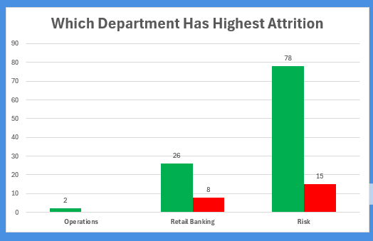
Department-wise HR Analytics Dashboard Panel

7.3 Salary Analysis

7.3.1 Overall Salary Distribution
The salary distribution across the 129 employees is highly skewed, reflecting the significant hierarchical stratification typical of banking organizations. The mean monthly salary is INR 6,292, but the median is only INR 4,809, indicating that the majority of employees earn below the average, with a relatively small number of high earners pulling the mean upward. The minimum salary recorded is INR 1,232 and the maximum is INR 19,545, representing a nearly 16x differential between the lowest and highest-paid employees.

Statistic | Value (INR/Month)
Mean Salary | 6,292
Median Salary | 4,809
Minimum Salary | 1,232
Maximum Salary | 19,545
Standard Deviation | 4,715
25th Percentile | 2,859
75th Percentile | 7,637

7.3.2 Salary by Job Role
The salary differential across job roles is the most dramatic compensation finding in this dataset. Branch Managers earn an average of INR 16,623 per month, which is 3.8 times the average salary of Relationship Managers (INR 4,335) and approximately double that of Risk Analysts (INR 8,502). This steep gradient creates a visible ceiling effect: Relationship Managers who cannot advance to Branch Manager roles may perceive their compensation growth potential as limited and begin exploring external opportunities.

Job Role | Employees | Average Salary (INR) | Min | Max
Branch Manager | 8 | 16,623 | ~10,000 | 19,545
Risk Analyst | 37 | 8,502 | ~2,000 | 19,537
Relationship Manager | 84 | 4,335 | 1,232 | ~15,000

The salary distribution within the Relationship Manager role shows considerable variation, with a standard deviation suggesting that even within this role, there are significant differences based on experience, location, and performance. This internal equity issue can be a source of dissatisfaction if employees become aware of the pay gaps among their peers.

7.3.3 Salary by Department
Department | Employees | Mean Salary (INR) | Median Salary (INR)
Operations | 2 | 18,086 | 18,086
Retail Banking | 34 | 6,845 | 5,609
Risk | 93 | 5,837 | 4,011

The Risk department, which is also the largest and has the highest flight risk concentration, has the lowest median salary at INR 4,011. This means half of all Risk department employees earn less than INR 4,011 per month, a figure that is arguably insufficient compensation for the technical and cognitive demands of risk management roles in banking. This compensation inadequacy is a systemic driver of the elevated attrition and flight risk scores observed in the Risk department.

7.3.4 Salary and Attrition Relationship
Attrition Status | Mean Salary (INR) | Median Salary (INR)
Still Employed (No) | 6,610 | 5,016
Left Organization (Yes) | 4,829 | 3,407

Employees who have left the organization earned, on average, INR 1,781 less per month than those who are still employed. The median salary of attrited employees (INR 3,407) is only 68% of the median salary of retained employees (INR 5,016). This confirms that lower salary is a reliable predictor of attrition in this organization, reinforcing the compensation-retention link identified throughout the analysis.

7.4 Performance Analysis

7.4.1 Performance Rating Distribution
The organization uses a four-point performance rating scale, with 1 representing the lowest performance and 4 representing the highest. The distribution of performance ratings across the 129 employees reveals a pronounced clustering at Rating 3, which accounts for 72.1% of all employees. This is a classic "leniency bias" pattern common in organizational performance management systems, where managers tend to avoid assigning the lowest ratings to avoid conflict and the highest ratings due to budget constraints on bonuses.

Performance Rating | Label | Count | Percentage
1 | Low / Poor | 4 | 3.1%
2 | Below Average | 7 | 5.4%
3 | Meets Expectations | 93 | 72.1%
4 | Outstanding | 25 | 19.4%

7.4.2 Performance Rating and Attrition
Performance Rating | Total | Attrited | Retained | Attrition Rate
1 (Poor) | 4 | 3 | 1 | 75.0%
2 (Below Avg) | 7 | 0 | 7 | 0.0%
3 (Meets Expectations) | 93 | 17 | 76 | 18.3%
4 (Outstanding) | 25 | 3 | 22 | 12.0%

The relationship between performance and attrition is non-linear and reveals two distinct risk groups. Rating 1 employees have a devastating attrition rate of 75%, meaning three out of four of the lowest-rated employees have already left. This could reflect involuntary separations (the organization managing out poor performers) or voluntary exits by disengaged employees who sense that their continued employment is precarious. Interestingly, Rating 2 employees have zero attrition, which may reflect a small sample size effect or indicate that these employees, while below average, are not at immediate risk.

Outstanding performers (Rating 4) have an attrition rate of 12%, which, while lower than the organization average, still represents a talent loss that is costly and disruptive. High-performing employees who leave are typically recruited away by competitors offering better compensation or career opportunities. Retaining top performers requires not just competitive pay but also recognition programs, career development investments, and meaningful work assignments.

7.4.3 Job Involvement and Engagement
Metric | Retained Employees | Attrited Employees
Average Job Involvement Score | 2.79 | 2.26
Average Work-Life Balance Score | 2.78 | 2.65
Average Job Satisfaction Score | 2.79 | 2.87
Average Training Times Last Year | 2.82 | 2.61

The job involvement score is notably lower for attrited employees (2.26 vs. 2.79), suggesting that employees who left were less engaged and less invested in their job responsibilities. Lower job involvement is both a cause and consequence of disengagement, and it serves as an early warning signal of impending departure. The marginal difference in job satisfaction scores (2.87 for attrited vs. 2.79 for retained) is smaller than expected, suggesting that employees may not express dissatisfaction directly but demonstrate it through reduced involvement and eventual departure.

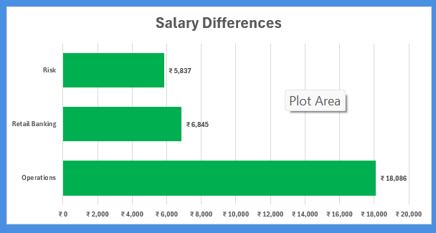Performance Rating Distribution and Attrition Rate Overlay

7.5 Flight Risk Model Analysis

The Flight Risk Model is the predictive centerpiece of this project. It operationalizes the intuition that certain combinations of employee characteristics make an individual significantly more likely to leave the organization. By converting qualitative risk factors into quantifiable scores and aggregating them into a composite Total_Risk_Score, the model enables HR to prioritize retention interventions on employees who are most at risk before they resign.

7.5.1 Risk Score Components
The Total_Risk_Score is built from four component sub-scores, each capturing a different dimension of flight risk:

Risk Component | Variable Used | Logic
Risk_Salary | Salary | Higher score for employees in lower salary bands
Risk_Tenure | Tenure | Higher score for employees with very short tenure
Risk_Performance | PerformanceRating | Higher score for employees with poor performance
Risk_Overtime | OverTime | Higher score for employees who regularly work overtime

7.5.2 Risk Category Distribution
Risk Category | Score Range | Employees | Percentage
Low | 0–2 | 76 | 58.9%
Medium | 3–4 | 36 | 27.9%
High | 5+ | 17 | 13.2%

The model categorizes 17 employees (13.2% of the workforce) as High Risk, 36 (27.9%) as Medium Risk, and 76 (58.9%) as Low Risk. The Medium Risk group is also significant: 25.0% of Medium Risk employees have already attrited, and the remaining 27 retained employees in this group represent a substantial at-risk pipeline that could transition to High Risk under adverse conditions such as a failed promotion cycle, a salary freeze, or increasing overtime demands.

7.5.3 Risk Category vs. Actual Attrition
Risk Category | Total | Attrited | Retained | Attrition Rate
High | 17 | 8 | 9 | 47.1%
Medium | 36 | 9 | 27 | 25.0%
Low | 76 | 6 | 70 | 7.9%
Total | 129 | 23 | 106 | 17.8%

The Flight Risk Model demonstrates strong predictive accuracy. High Risk employees have an attrition rate of 47.1%, which is approximately 6 times the attrition rate of Low Risk employees (7.9%). This clear separation between risk tiers validates the model's design and confirms that the four risk variables (Salary, Tenure, Performance, Overtime) collectively capture meaningful predictive information about an employee's likelihood of leaving.

From a practical standpoint, this means that the HR team can focus its retention efforts on the 17 High Risk employees and 36 Medium Risk employees, representing just 41% of the workforce, while being confident that this group contains approximately 74% (17 out of 23) of all employees who have left or are likely to leave. This prioritization significantly enhances the efficiency of retention investment.

7.5.4 Profile of High Risk Employees
Characteristic | High Risk Employee Profile
Total Count | 17 employees
Already Attrited | 8 employees (47.1%)
Works Overtime | 16 out of 17 (94.1%)
Department | 13 in Risk, 4 in Retail Banking
Average Salary | INR 4,328/month
Average Tenure | 3.82 years
Risk_Category | High (Score 5+)

The profile of a High Risk employee is striking: 94.1% of them work overtime, their average salary of INR 4,328 is well below the organizational average of INR 6,292, and their average tenure of only 3.82 years suggests they are still relatively early in their organizational journey with the company. This combination of high workload, low compensation, and relatively low organizational investment in their tenure makes them highly vulnerable to poaching or voluntary exit.

Key Insight: Of the 17 High Risk employees, 16 work overtime. This makes overtime the single most decisive risk factor in the Flight Risk Model, and reducing overtime burden for this group is the most impactful immediate lever available to HR for attrition prevention.

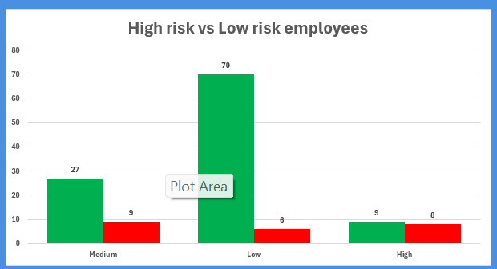 Risk Category Distribution and Attrition Overlay

Chapter 8: Results and Discussion

8.1 Summary of Key Findings

Finding | Key Metric | Business Implication
Overall attrition rate | 17.8% (23 of 129 employees) | Above industry average; systemic HR risk
Highest departmental attrition | Retail Banking: 23.5% | Branch network stability at risk
Overtime-driven attrition | 37.2% for OT workers vs. 8.1% for non-OT | Workload management is a priority intervention area
Gender attrition gap | Male: 21.2% vs Female: 12.2% | Targeted retention for male employees needed
Marital status vulnerability | Single: 28.6% attrition | Career development programs key for single employees
Mumbai attrition hotspot | 33.3% - highest city-wise rate | Location-specific HR strategy required
Low salary band attrition | 33.3% for salary below INR 2,500 | Compensation revision needed at entry levels
Poor performer attrition | 75.0% for Rating 1 employees | Performance management and PIP processes needed
High Risk Model accuracy | 47.1% actual attrition in High Risk group | Model is operationally reliable for use
Branch Manager salary premium | INR 16,623 vs INR 4,335 for RM | Career path clarity and pay progression critical

8.2 Business Impact Discussion
The combination of a 17.8% attrition rate and the concentration of flight risk among overtime workers and low-salary employees points to a structural misalignment between the demands placed on frontline banking staff and the rewards they receive. In banking, where relationship continuity is crucial for customer retention, every employee departure carries both a direct cost (recruitment, onboarding, training) and an indirect cost (customer relationship disruption, team morale impact, knowledge loss).

The Flight Risk Model's identification of 17 High Risk employees provides a concrete list for immediate HR action. If these employees leave, the organization faces the prospect of losing nearly all of one operational team or multiple relationship manager positions simultaneously, which could disrupt branch-level service delivery.

The salary analysis reveals that the organization is operating with a compensation structure that may have become misaligned with market rates, particularly for entry-level Relationship Managers. The INR 4,335 average salary for the 84 Relationship Managers in the dataset is below the cost-of-living thresholds in cities like Mumbai and Bangalore, creating a recruitment and retention disadvantage relative to competitor banks and the fintech sector.
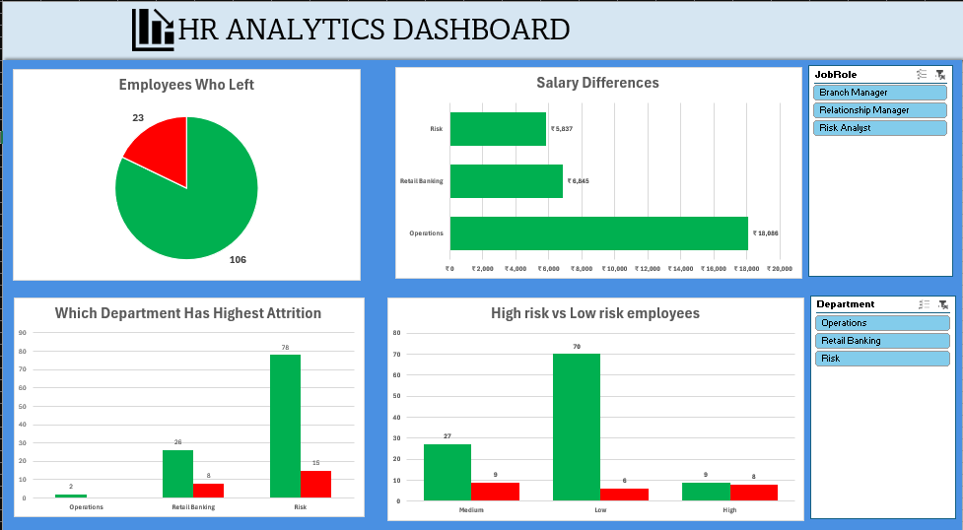

8.3 Strategic Recommendations

8.3.1 Overtime Reduction and Workload Redistribution
Given that 37.2% of overtime workers have left, and that 16 out of 17 High Risk employees are overtime workers, this is the highest-priority intervention. The HR team should work with department heads to audit the overtime patterns, identify structural causes such as understaffing or inefficient task allocation, and implement workload redistribution measures. Where overtime is unavoidable, appropriate compensation through overtime pay or compensatory off should be ensured.

8.3.2 Compensation Review for Entry-Level Roles
A structured compensation benchmarking exercise should be conducted for Relationship Managers, particularly in the Low and Mid salary bands. Salary increments of even 15-20% for the bottom quartile could significantly reduce attrition in this group, given the direct relationship between compensation and retention demonstrated in the data.

8.3.3 Targeted Retention for Single Employees
Single employees constitute 38% of the workforce but contribute 60.9% of all attritions. Engaging this group through mentorship programs, structured career roadmaps, social engagement initiatives, and fast-track promotion pathways can improve their sense of organizational belonging and career progression clarity.

8.3.4 Mumbai Branch-Specific Intervention
The Mumbai branch has an attrition rate of 33.3%. An immediate HR audit of the Mumbai branch should be conducted, including exit interview analysis, workload assessment, and a salary benchmarking exercise specific to Mumbai's cost of living. Location-specific retention allowances could be considered.

8.3.5 Proactive Engagement of High Risk Employees
The 9 remaining High Risk employees who have not yet left should be individually engaged by their HR business partners and line managers. Stay interviews, career development conversations, salary reviews, and workload adjustments should be initiated proactively rather than waiting for resignation notices.

Chapter 9: Challenges Faced

9.1 Incomplete Risk Score Column
The 'Risk Score' column was largely null. After examination, it was determined to be a precursor superseded by Total_Risk_Score. The partially populated column was excluded to avoid double-counting and misleading conclusions.

9.2 Small Sample Sizes in Some Segments
Operations (2 employees) and Mumbai (18 employees) are too small for robust statistical inference. All rate-based findings for these segments were flagged with absolute counts so readers could assess reliability — e.g., Mumbai's 33.3% rate is 6 departures from a base of 18.

9.3 Artifact Columns
Two unnamed export-artifact columns (Unnamed: 35 and Unnamed: 36) at the end of the EmployeeMaster sheet were identified during initial inspection and excluded from all analytical operations.

9.4 Non-Linear Attrition Patterns
Rating 2 employees showed zero attrition while Rating 1 showed 75%, defying a simple linear interpretation. This required distinguishing between voluntary exits by disengaged employees and involuntary separations managed by the organization — an ambiguity acknowledged rather than forced into a single narrative.

9.5 Counterintuitive Business Travel Finding
Frequent travelers showed lower attrition (12.5%) than rare travelers (21.3%). This was resolved by recognising that frequent business travel typically correlates with senior, better-compensated roles — meaning travel is a proxy for seniority, not a standalone stress driver.

9.6 Dashboard Limitations in Excel
Excel's charting constraints (limited custom chart types, no native scatter regression lines) meant some relationships could only be approximated with standard chart types. Dynamic slicer links required careful pivot table source configuration to avoid desynchronisation.

Chapter 10: Conclusion

This project applied HR analytics to a 129-employee banking dataset to generate actionable insights into attrition, compensation, performance, and flight risk. All stated objectives were achieved.

The organization's 17.8% attrition rate is driven by a convergence of factors: inadequate entry-level compensation, an unsustainable overtime culture, and location-specific pressures in Mumbai. Retail Banking (23.5% attrition) and single employees (28.6%) are the highest-priority retention segments.

The Flight Risk Model correctly identifies a High Risk group where 47.1% of employees have already left versus only 7.9% in the Low Risk group — a 6x differential that validates it as a practical decision-support tool. Overtime is the single most powerful attrition driver: employees working overtime are 4.6x more likely to leave. Addressing workload distribution is the highest-impact lever available to HR leadership.

These findings demonstrate that standard tools like Excel, when applied with analytical rigour, can produce insights that are nuanced, reliable, and directly actionable — translating 23 individual departures and dozens of at-risk employees into a clear strategic agenda for the organisation's HR team.

Chapter 11: Future Scope

11.1 Longitudinal Attrition Tracking
The current dataset is a single snapshot. Tracking the same workforce across multiple years would reveal seasonal attrition patterns, measure the impact of HR interventions, and significantly strengthen the Flight Risk Model's predictive power.

11.2 Machine Learning-Based Predictive Modeling
Replacing the rule-based scoring model with algorithms such as logistic regression, random forest, or gradient boosting would capture non-linear variable interactions and produce individual-level attrition probability scores with confidence intervals.

11.3 NLP on Exit Interviews
If exit interview transcripts are digitised, sentiment analysis and topic modeling could systematically identify the most frequently cited departure reasons — complementing quantitative findings with direct employee voice data.

11.4 Real-Time HRIS Integration
Connecting the dashboard and risk model to a live HRIS (SAP HCM, Oracle HCM, Workday) would enable monthly score recalibration and automated HR alerts when an employee's risk score crosses a predefined threshold.

11.5 Peer Bank Benchmarking
Extending the analysis across peer banks of similar size would allow benchmarking of attrition rates, compensation structures, and risk scores against industry norms — clarifying whether the organisation's challenges are idiosyncratic or sector-wide.

11.6 Pulse Survey Integration
Replacing annual self-reported satisfaction scores with monthly pulse surveys would provide a more dynamic, real-time leading indicator of engagement decline — enabling earlier intervention before attrition risk materialises.

References

- Cascio, W. F., & Boudreau, J. W. (2011). Investing in People: Financial Impact of Human Resource Initiatives (2nd ed.). FT Press.
- Davenport, T. H., Harris, J., & Shapiro, J. (2010). Competing on Talent Analytics. Harvard Business Review, 88(10), 52–58.
- Fitz-enz, J. (2010). The New HR Analytics: Predicting the Economic Value of Your Company's Human Capital Investments. AMACOM.
- Harter, J. K., Schmidt, F. L., & Hayes, T. L. (2002). Business-unit-level relationship between employee satisfaction, employee engagement, and business outcomes. Journal of Applied Psychology, 87(2), 268–279.
- IBM Watson Analytics (2017). HR Employee Attrition and Performance Dataset. IBM Developer Community.
- Indian Banks' Association (2023). Banking Industry HR Report: Attrition, Compensation, and Talent Management Trends. IBA Publications.
- Mobley, W. H. (1977). Intermediate linkages in the relationship between job satisfaction and employee turnover. Journal of Applied Psychology, 62(2), 237–240.
- SHRM Foundation (2016). Use of Workforce Analytics for Competitive Advantage. Society for Human Resource Management.

Appendix - Excel Model Screenshots

Final Dashboard
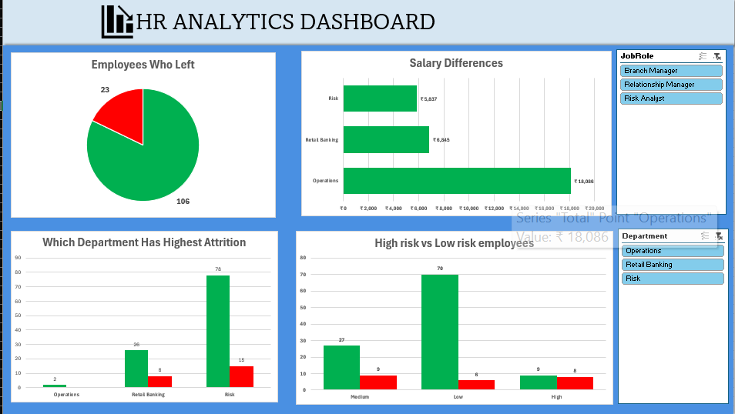

Insights & Recommendations

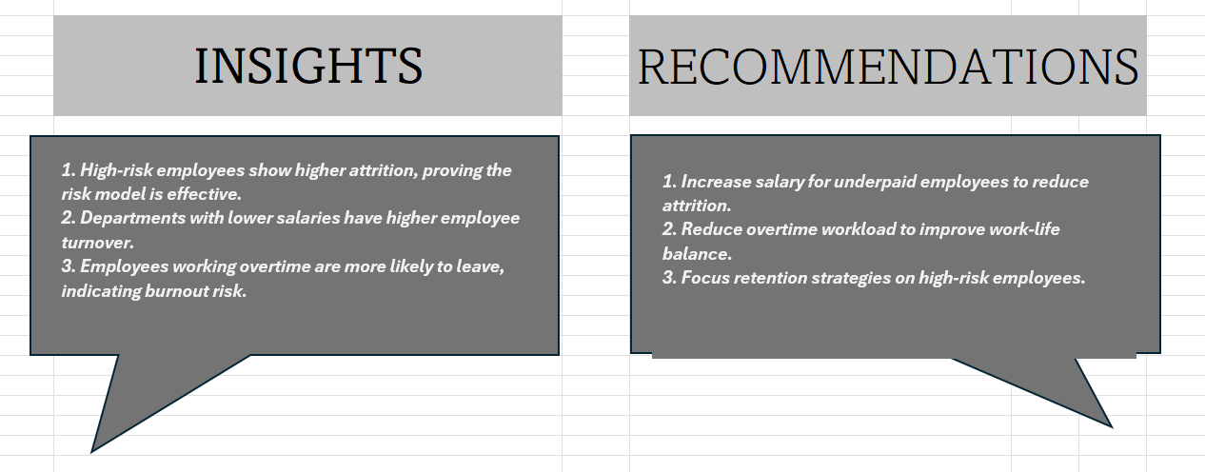

RISK vs ATTRITION

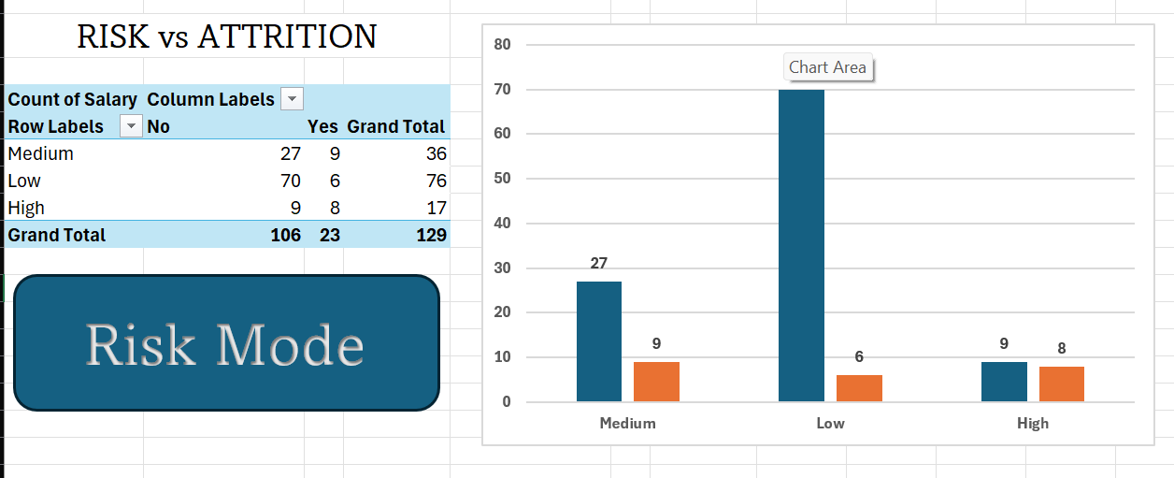 Pivott Analysis

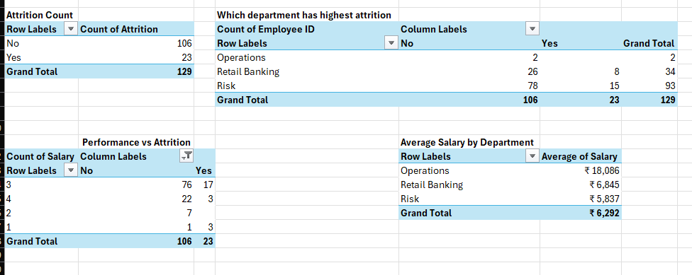

Dataset

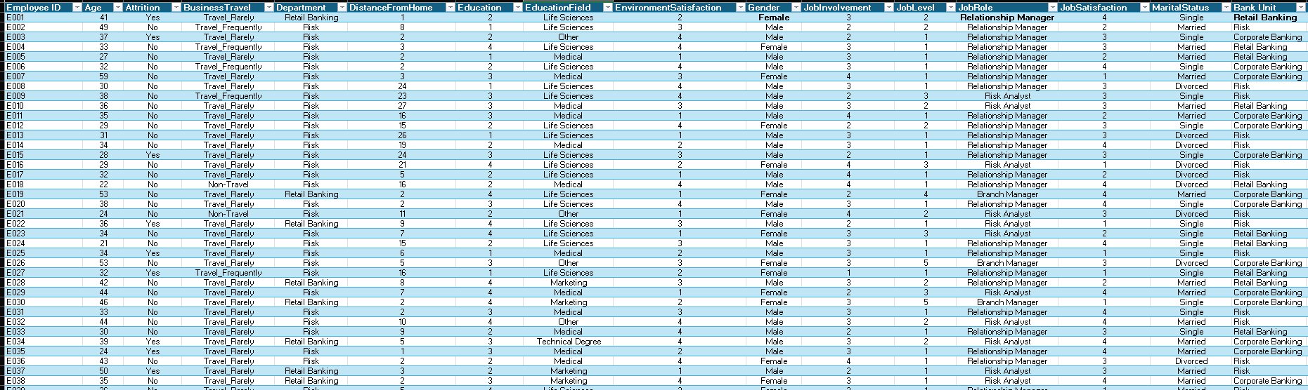

--- End of Report ---
HR Analytics for Banking Sector

